**WATER PURIFICATION ANALYSIS**

WHY PURIFY WATER?

* Water is of major importance to all living things.
* We purify water to get rid of contaminants that can be detrimental to our health.
* Up to 60 percent of the human body is Water.
* Therefore the quality of Water we drink is very important.
* The Drinking Water should be totally clean, pure and free of any disease causing MICROBES, and that’s why it should be properly Treated and DISINFECTED before using it for drinking purpose.

**RESEARCH ON DRINKING WATER PURIFICATION**

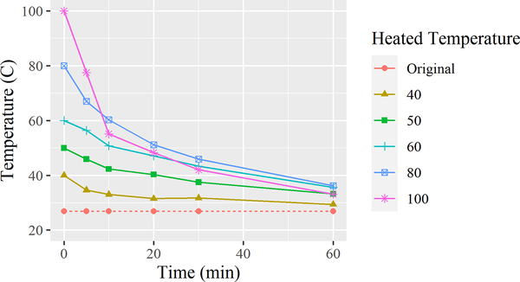

**Anomaly detection techniques for water quality parameters can be broadly divided into two categories:**

1. Statistical methods
2. Machine learning methods

**1.Statistical methods:**

* These methods identify anomalies by looking for data points that deviate significantly from the expected distribution. Some common statistical methods for anomaly detection include:

Thresholding:

* This method involves setting a threshold for each parameter, and flagging any data points that fall above or below the threshold.

Changepoint detection:

* This method identifies changes in the mean, variance, or trend of the data over time.

Clustering:

* This method groups similar data points together, and then flags any data points that fall outside of the clusters.

**2.Machine learning methods:**

* These methods use machine learning algorithms to train a model on historical water quality data. The trained model can then be used to identify anomalous data points in new data. Some common machine learning methods for anomaly detection include:

Support vector machines (SVMs):

* SVM algorithms create a hyperplane that separates normal data points from anomalous data points.

Decision trees:

* Decision trees learn a set of rules that can be used to classify data points as normal or anomalous.

Neural networks:

* Neural networks are complex machine learning models that can learn complex patterns in data. Neural networks can be used for anomaly detection by training them to distinguish between normal and anomalous data points.

**Anomaly detection techniques**

The choice of anomaly detection technique will depend on a number of factors, including the type of water quality data being collected, the specific anomalies that need to be detected, and the resources available.

In addition to the above methods, there are a number of other anomaly detection techniques that can be used for water quality data. For example, ensemble methods combine the outputs of multiple anomaly detection algorithms to improve accuracy. Deep learning methods, such as recurrent neural networks (RNNs) and long short-term memory (LSTM) networks, can be used to detect anomalies in time series data.

Here are some specific examples of how anomaly detection techniques have been used to identify unusual patterns in water quality parameters:

Machine learning algorithms have been used to detect anomalies in turbidity data. Turbidity is a measure of the cloudiness of water, and it can be caused by a variety of factors, including pollution, algae blooms, and erosion. By detecting anomalies in turbidity data, water quality managers can identify potential problems early on and take steps to address them.

Statistical methods have been used to detect anomalies in pH data. pH is a measure of the acidity or alkalinity of water. Anomalous pH levels can be caused by a variety of factors, including industrial pollution and agricultural runoff. By detecting anomalies in pH data, water quality managers can identify potential problems that could harm aquatic life.

Deep learning methods have been used to detect anomalies in dissolved oxygen (DO) data. DO is a measure of the amount of oxygen dissolved in water. Low DO levels can be harmful to aquatic life. By detecting anomalies in DO data, water quality managers can identify potential problems that could lead to fish kills and other environmental damage.

**The steps to create a water purification analysis project using Python:**

**1. Collect water quality data**

* . This data can be collected from various sources, such as government agencies, water utilities, or environmental organizations. The data include information on the physical, chemical, and biological properties of the water, such as pH, turbidity, dissolved oxygen, and coliform bacteria.

**2. Preparing the data for analysis**

* . This may involve cleaning the data, removing outliers, and normalizing the data
* .

**3. Analyzing the data using Python**

* . There are many Python libraries that can be used for water quality analysis, such as NumPy, Pandas, Matplotlib, and Seaborn.

**4. Visualize the data.**

* This can be done using Python libraries such as Matplotlib and Seaborn. Visualization can help you to identify patterns and trends in the data.

**5. Model the data.**

* This can be done using machine learning algorithms, such as decision trees, random forests, and support vector machines. Modeling can help you to predict the quality of water based on its physical, chemical, and biological properties.

**6. Interpret the results.**

* This involves understanding the meaning of the results and how they can be used to improve water quality